Graphical User Interface
GitHub: https://github.com/yaswanthsingampalli/Endure_robotics/tree/main/robot_ui_launcher_ws

Prerequisites
- ROS 2 Humble installed and sourced (Ubuntu 22.04.5 LTS).
- Python 3 with Flask and Gunicorn installed.
- Both robot_ui_launcher_ws and airport_navigation_ws workspaces cloned and accessible.
- Check Readme to download all the dependencies

Workspace Overview: The robot_ui_launcher_ws is a ROS 2 workspace focused on providing a web-based user interface (UI) for controlling and monitoring the autonomous robot system. It hosts a Flask-based backend server and a frontend web UI, enabling operators to launch, stop, or manage robot navigation missions easily through a browser. This workspace acts as a bridge between the operator and the robot's core ROS 2 navigation stack, providing an intuitive interface for mission management without needing direct command-line interaction with ROS 2.

Purpose and Benefits

1) Simplifies Mission Control:
Operators can start, stop, and restart navigation missions with a click, improving operational efficiency.
2) Removes Need for Direct ROS Interaction:
The UI abstracts away complex ROS 2 commands, making robot control accessible to non-expert users.
3) Supports Remote Access:
The server runs on port 8081 and can be accessed remotely via any web browser on the same network.
4) Production-ready Backend:
Uses Gunicorn WSGI server for stable and performant HTTP request handling.

Repository Structure:
├── logs
├── start_server.sh
├── static
│ ├── app.js
│ ├── logo.jpeg
│ └── styles.css
├── templates
│ └── index.html
├── ui_server.py

Scripts Description

Startup Automation (ui_server.py):

A Flask-based web server implementing API endpoints for:

Launching ROS 2 navigation missions

Stopping or restarting existing launches

Monitoring mission status in real-time
Communicates with ROS 2 using subprocess calls to run launch files and system commands.
Serves the web UI frontend (HTML/JS) to clients.

Backend (Flask Server - start_server.sh):
Automates the startup sequence:
Builds both the UI workspace (robot_ui_launcher_ws) and the main robot navigation workspace (airport_navigation_ws).
Sources the necessary ROS 2 environment.
Starts the UI server using Gunicorn on port 8081.
Opens the default web browser automatically to the UI page (http://localhost:8081).

Web Interface (Frontend – index.html, styles.css, app.js):

Buttons:

Start Mission: Calls /start, launches navigation.

Stop Mission: Calls /stop, kills the launch process.

Restart Mission: Stops and then starts navigation.

Manual Control: Placeholder for future manual override feature.

Status Display:

A live text indicator (Status: Idle / Launched / Stopped / Running) with color-coded updates reflects backend responses.

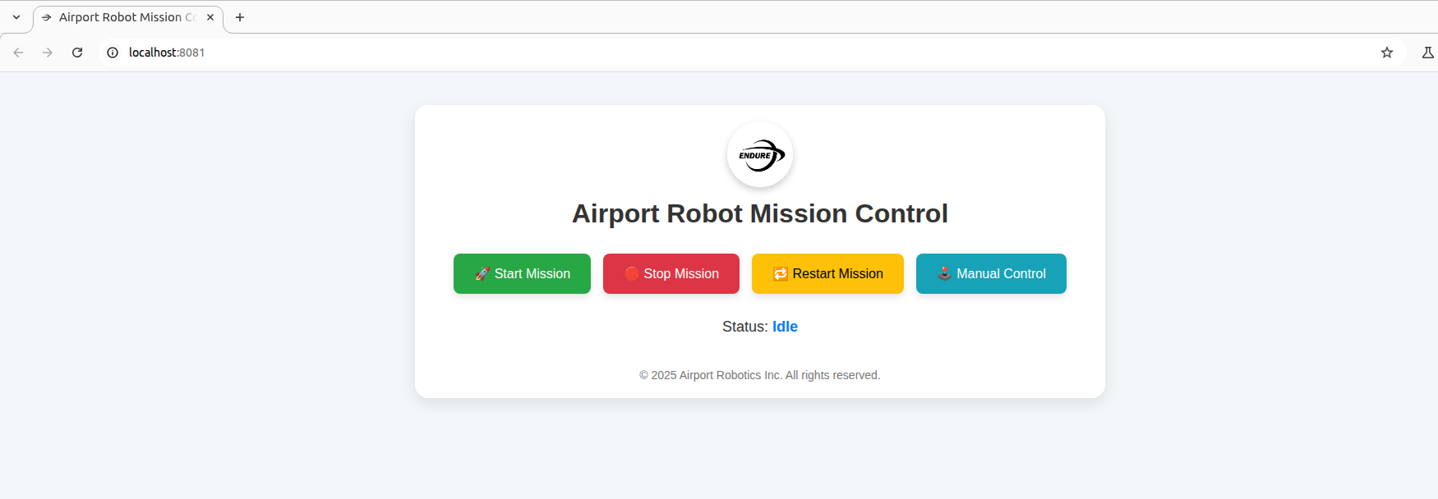
Web Interface:

Navigation Interface:

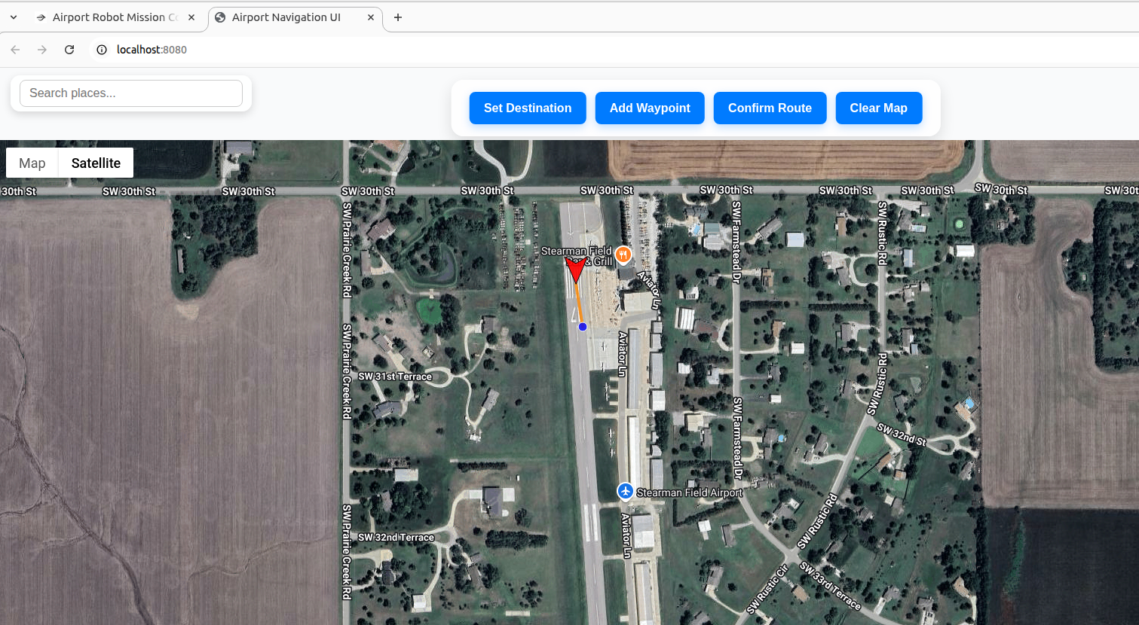

Example JS Function:

function sendCommand(cmd) {

fetch(`/${cmd}`)

.then(response => response.json())

.then(data => {

document.querySelector('.status-text').innerText = data.status;

// Update color based on state

});

}

Launching the UI Server
- Make sure ROS 2 is sourced:
source /opt/ros/humble/setup.bash
- Run the startup script:
chmod +x start_server.sh
./start_server.sh
- This will:
Build necessary workspaces
Start the UI server on http://localhost:8081
Open the UI automatically in your default browser

Accessing the UI
- When ./start_server.sh it will automatically launches a window in your browser
- If you want to access the UI locally from remote then your local system and the robot needs to connect to same network and then type the below Url in your local browser

http://<jestson_ip address>:8081

How It Helps the Robot System
Bridges Human-Robot Interaction: Operators don’t need to know ROS commands or manage multiple terminal windows.
Improves Reliability: Centralized mission control reduces manual errors.
Enables Remote Operation: Run or rerun missions from anywhere on the network.
Supports Rapid Development: Easy to integrate new features or diagnostics in the UI backend.

